ASG AIRLINES: END-TO-END DATA ENGINEERING CASE STUDY
Data Engineering Internship Project

Submitted by:
Priyanshi Acharya
Master of Computer Applications (MCA)
VIT Bhopal University

1. PROJECT OVERVIEW
The ASG Airlines End-to-End Data Engineering Case Study focuses on developing a structured data engineering pipeline for processing airline operational data. The project begins with a raw Excel workbook containing multiple datasets and progresses through data ingestion, quality assessment, cleaning, transformation, validation, analytical modeling, and business intelligence visualization.
Python and Pandas are used to implement the data processing pipeline, while Power BI is used to develop an interactive Flight Operations Dashboard. The resulting system provides operational insights including flight volume, airline distribution, route traffic, flight duration, departure periods, and overnight flight activity.
The project follows a layered architecture consisting of the raw data layer, processing and pipeline layer, local storage layer, analytics/data model layer, and visualization/reporting layer.

2. PROBLEM STATEMENT
Airline operational data is often stored in raw and heterogeneous formats that require systematic processing before it can be used for analysis and reporting.
The objective of this case study is to build an end-to-end data engineering workflow that:
- Ingests the provided airline dataset.
- Performs data quality and integrity checks.
- Cleans and prepares the data for analysis.
- Creates useful derived attributes.
- Calculates flight duration and identifies overnight flights.
- Validates the processed data.
- Produces an analytical dataset and KPI model.
- Presents operational insights through an interactive Power BI dashboard.
The workflow is designed to provide a reliable and reproducible foundation for airline operational analysis.

3. OBJECTIVES
The main objectives of the project are:
- Data Ingestion
Import and inspect the raw airline Excel workbook.
- Data Quality Assessment
Identify null values, duplicates, malformed records, and other data-quality issues.
- Data Cleaning
Remove duplicate records, standardize relevant fields, and protect personally identifiable information.
- Data Transformation
Generate routes, extract time-based attributes, categorize departure periods, and prepare analytical fields.
- Flight Analysis
Calculate flight duration and identify overnight flights.
- Data Validation
Perform automated validation checks on the processed datasets.
- Analytical Modeling
Prepare the final flight dataset and KPI model for reporting.
- Visualization
Build an interactive Power BI dashboard for airline operational analysis.
- Version Control
Maintain the project using Git and GitHub.

4. DATASET DESCRIPTION
The project uses the provided UseCase - Airlines.xlsx workbook as the raw data source.
The workbook contains four sheets:
Sheet | Description
Flights | Flight-related operational information
Payments | Payment-related records
Bookings | Booking information
Passengers | Passenger-related information

The raw workbook is maintained under:
data/raw/UseCase - Airlines.xlsx
The processed and analytical outputs are stored under:
data/processed/
The pipeline preserves the raw source as an immutable reference while producing cleaned and transformed datasets for downstream analysis.

5. TECHNOLOGY STACK
The following technologies and tools were used in the implementation of the project:
Technology / Tools | Purpose
Python | Core data engineering and processing
Pandas | Data ingestion, cleaning, transformation, and analysis
Microsoft Excel | Source data format
Jupyter Notebook | Data exploration and pipeline analysis
VS Code | Development and code management
Power BI | Interactive dashboard and visualization

6. SYSTEM ARCHITECTURE
The project follows a layered data engineering architecture.
Architecture Layers
1. Raw Data Layer
- UseCase - Airlines.xlsx
- Located in data/raw/
- Contains four source sheets: flights, payments, bookings, and passengers.
2. Processing & Pipeline Layer
- Python 3.14
- Pandas
- Data ingestion
- Quality checks
- Cleaning
- Transformation
- Flight duration and overnight processing
- Validation
- KPI generation
3. Local Storage Layer
- data/raw/
- data/processed/
- logs/
4. Analytics & Data Model Layer
- FactFlights
- Dimension tables including airline, route, and time dimensions
- KPI model
5. Visualization & Reporting Layer
- Microsoft Power BI Desktop
- Interactive ASG Airlines Flight Operations Dashboard
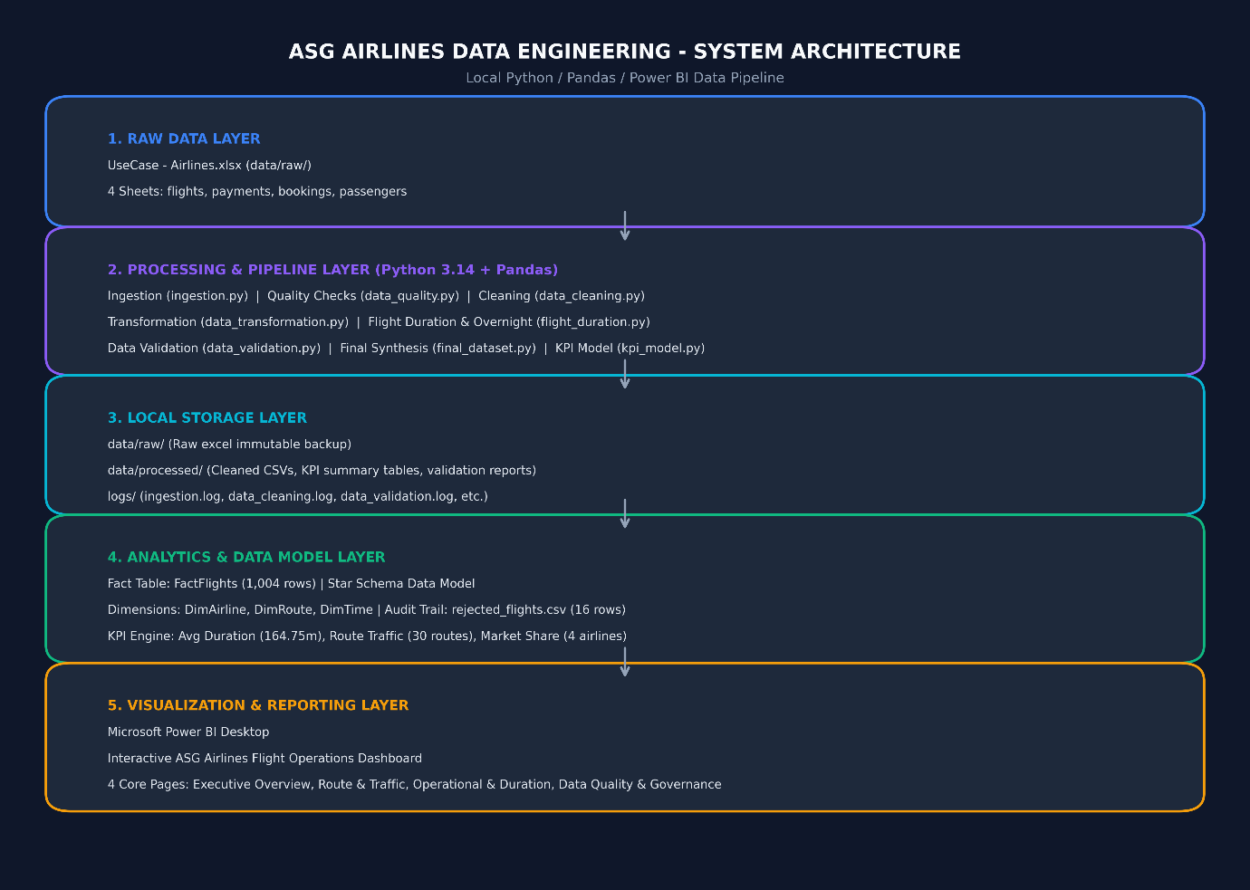
Figure 1: ASG Airlines End-to-End System Architecture

7. DATA FLOW
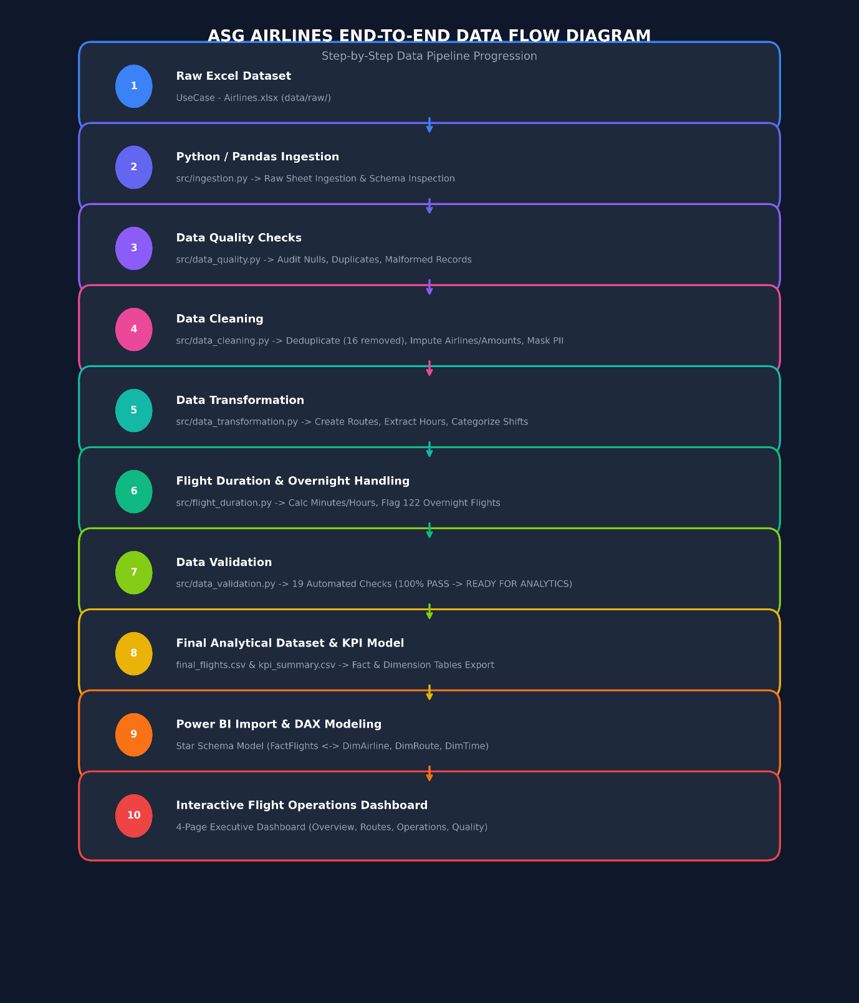
Figure 2: Data flow diagram

8. DATA ENGINEERING PIPELINE
The pipeline was implemented as a sequence of independent processing stages.
8.1 Data Ingestion
The raw Excel workbook is ingested using Python and Pandas. The ingestion process inspects the available sheets and their schemas while maintaining the original raw data unchanged.
8.2 Data Quality
The ingested data is assessed for common quality issues including:
- Null values
- Duplicate records
- Malformed records
- Data consistency issues
8.3 Data Cleaning
The cleaning stage prepares the data for downstream analysis. Duplicate records are removed and relevant fields are standardized. Passenger-related personally identifiable information is also handled through masking/protection measures.
The pipeline recorded 16 duplicate records removed during cleaning.
8.4 Data Transformation
The transformation stage creates analytical attributes including:
- Flight routes
- Departure and arrival hours
- Departure-period categories
- Other derived fields required for analysis
8.5 Flight Duration & Overnight Handling
Flight duration is calculated from the available flight time information and represented in minutes and hours.
The pipeline also identifies flights that operate across the overnight boundary.
The final analytical dataset contains 122 overnight flights.
8.6 Data Validation
Automated validation checks are executed after processing to verify the integrity and readiness of the final dataset.
The project architecture reports:
19 automated checks — 100% passed

9. DATA QUALITY & CLEANING
Data quality was treated as an important stage of the pipeline rather than performing analysis directly on the raw workbook.
The following checks and operations were incorporated:
Area | Implementation
Null checks | Identification of missing values
Duplicate checks | Detection and removal of duplicate records
Malformed records | Validation of data structure and values
PII protection | Passenger-related information handled securely
Standardization | Preparation of consistent analytical fields
Validation | Automated checks after processing

10. DATA TRANSFORMATION
The transformation stage converts the cleaned flight data into an analytical structure suitable for reporting.
The major transformations include:
- Route Creation: A route attribute is generated using the source and destination information.
- Time Extraction: Departure and arrival hours are extracted from the available time fields.
- Departure Period: Flights are categorized into periods such as Morning, Afternoon, Evening, and Night.
- Flight Duration: Flight duration is calculated and represented in minutes and hours.
- Overnight Identification: Flights crossing the overnight boundary are identified using the overnight flag.
- Analytical Attributes: Additional derived fields are prepared for Power BI analysis.
These transformations create a consistent dataset for operational analysis while keeping the raw source data unchanged.

11. KPI RESULTS
The final Power BI dashboard provides the following key metrics:
KPI | Result
Total Flights | 1,004
Average Flight Duration | 2.75 hours
Total Airlines | 4
Total Routes | 30
Overnight Flights | 122

The calculated average duration corresponds to approximately 164.75 minutes.
These KPIs provide a high-level view of flight volume, airline coverage, route coverage, and flight-duration characteristics.

12. DATA MODEL
The processed data is organized into an analytical model for Power BI.
The architecture contains:
Fact Table
FactFlights
- Contains 1,004 flight records
- Serves as the primary operational fact table.
Dimension Tables
The model includes dimensions for:
- DimAirline — airline information
- DimRoute — route information
- DimTime — time-related analytical attributes
KPI Model
The KPI layer supports measures such as:
- Average flight duration
- Route traffic
- Airline market share
- Overnight flight count
- Flight volume
This structure allows the Power BI dashboard to analyze flight operations across multiple dimensions.

13. POWER BI DASHBOARD
Microsoft Power BI Desktop was used to create an interactive ASG Airlines Flight Operations Dashboard.
The dashboard consists of four core pages:
13.1 Executive Overview
The Overview page presents the primary operational KPIs along with:
- Flights by airline
- Flights by source
- Flights by destination
- Overall flight volume
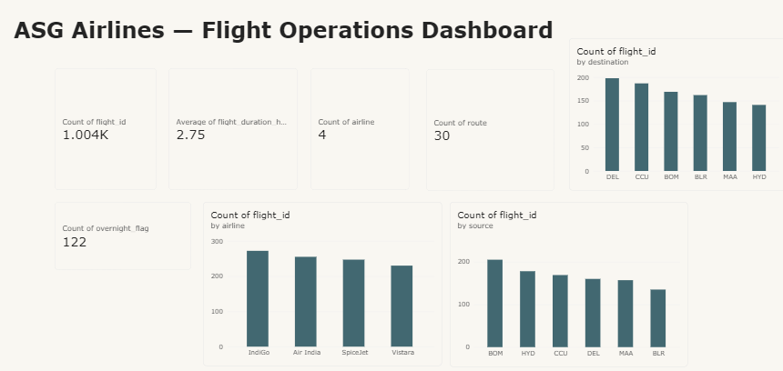
Figure 3: Executive Overview Dashboard

13.2 Duration Analysis
The Duration Analysis page focuses on flight-time characteristics.
It includes:
- Average flight duration
- Average duration by airline
- Average duration by departure period
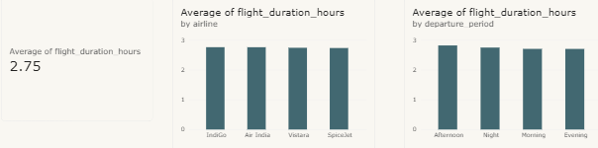
Figure 4: Flight Duration Analysis
13.3 Route Performance
The Route Performance page provides route and airport traffic analysis.
It includes:
- Flight count by route
- Flight count by source
- Flight count by destination
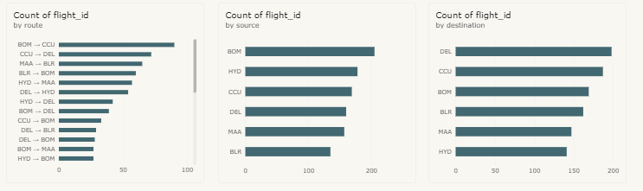
Figure 5: Route Performance Analysis

13.4 Airline & Anomaly
The Airline & Anomaly page presents:
- Airline distribution
- Duration-status analysis
- Overnight flight count
The current processed dataset classifies the displayed records as Valid under the implemented duration-status validation.
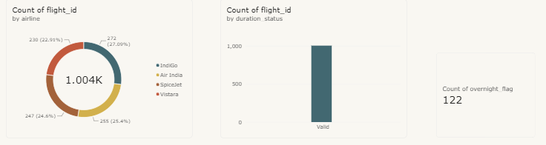
Figure 6: Airline and Data Quality Analysis

14. PII & DATA PRIVACY
Personally identifiable information (PII) was considered during the data-cleaning stage.
The pipeline includes measures to prevent unnecessary exposure of passenger-related information in analytical outputs. Passenger data is not required for the operational Power BI KPIs, so the analytical layer focuses primarily on flight, airline, route, and time attributes.
The raw data layer is also maintained separately from the processed analytical layer.
The project therefore follows the principle of minimizing exposure of sensitive passenger information while retaining the fields required for operational analysis.

